Hello, please follow this step by step guide to access a number of important services on the web site.

Update your profile
In order to receive notifications from the web site and to receive communication from the elder and other members, you will need to correctly configure your profile.
First, login to the website with the credentials you used to setup your account. If you have not setup an account, you will need to do this first.
Once you are logged in, please click on the MEMBERS tab (highlighted below)
You will now be on the Member Dashboard. Please click on the DIRECTORY link along the right side of the screen. 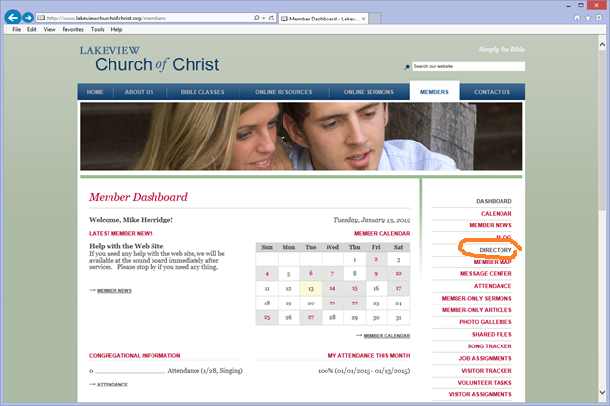

You are now in the Directory.
Please click on ‘EDIT YOUR DIRECTORY LISTING’
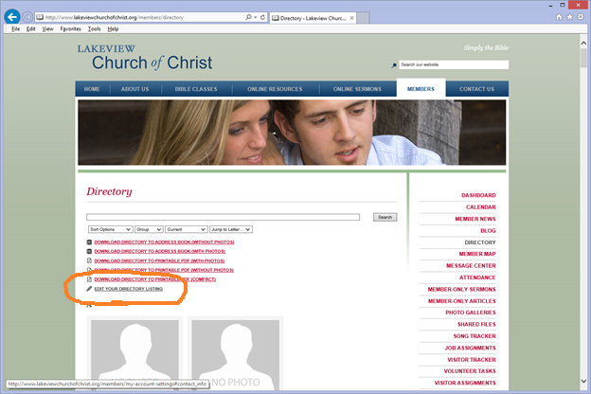

This is now your family’s directory page. You can edit your own or your families entry from here.
To edit your directory listing, click on the ‘YOU’ tab on this page.
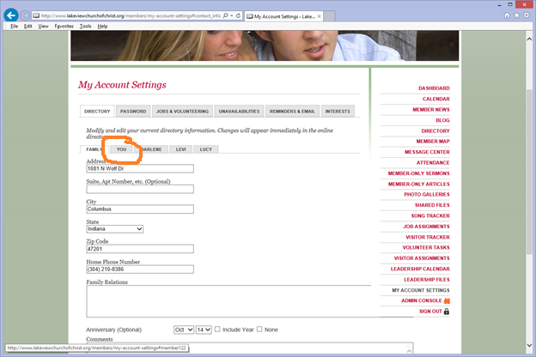

This is now your information. (You can edit any other family member by clicking on their tab.
PLEASE NOTE: In order to receive text messages, you must fill out the cell phone number AND the cell provider. Additionally, in order to receive email, you will need to fill out the email address. Please correctly fill these in. While you here, go ahead and check all your other information. You can add a picture to your page as well as your family’s page. Please find a good photo and add it to the page. It will help everyone know you better.
Be sure to click update at the bottom of the page once you are done making changes.
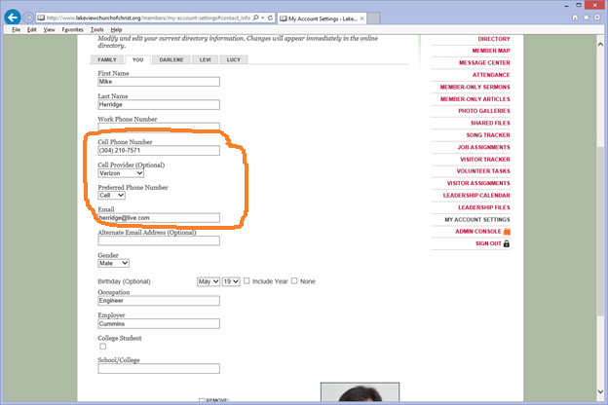

CONFIGURE YOUR NOTIFICATIONS
In order to receive notification from the website, you have to configure your account. The notifications that you receive are for upcoming jobs or responsibilities. These will typically come out the day before you are scheduled.
From your account settings, you need to click on the ‘REMINDERS & EMAIL” tab.

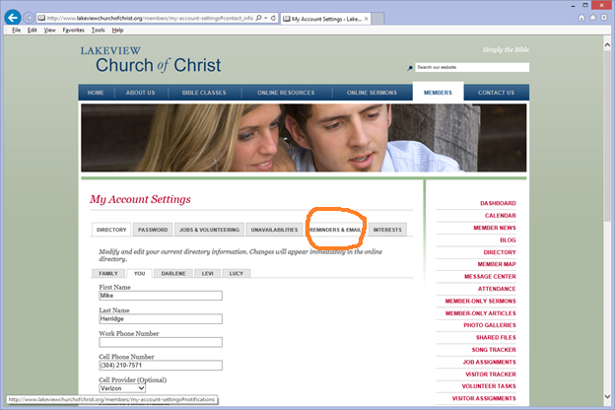

Once you get to the Reminders & Email tab, you need to choose how you want to receive notifications. Each type of notification is listed and you can choose from the drop down box how you want to receive them. Note from below: I have chosen to receive Job Assignments (assignment during the worship service), Volunteer Assignments (things like building cleaning), and Visitor Assignments (currently unused) but receiving a text message.
Be sure to click update when you are done.
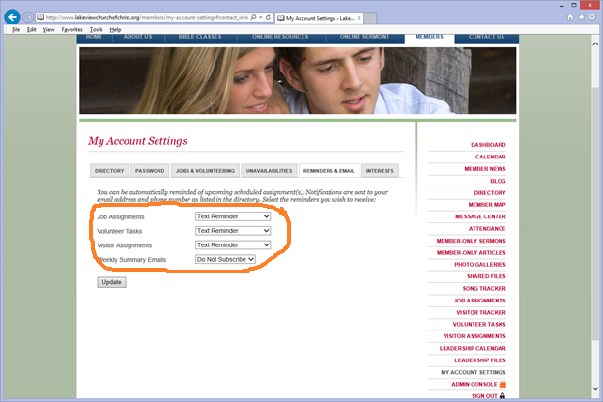

JOBS and VOLUNTEER tasks
Finally, you should choose the Jobs and Volunteer tasks tab.
On this tab, you will choose all the jobs that you are willing to do. The elders will review these requests and approve each area you have agreed to do. Based on this panel, you will then be put into the rotation for each job. These get assigned on a monthly basis and, if you signed up for the reminders, you will get a notification about upcoming jobs before you need to do them.
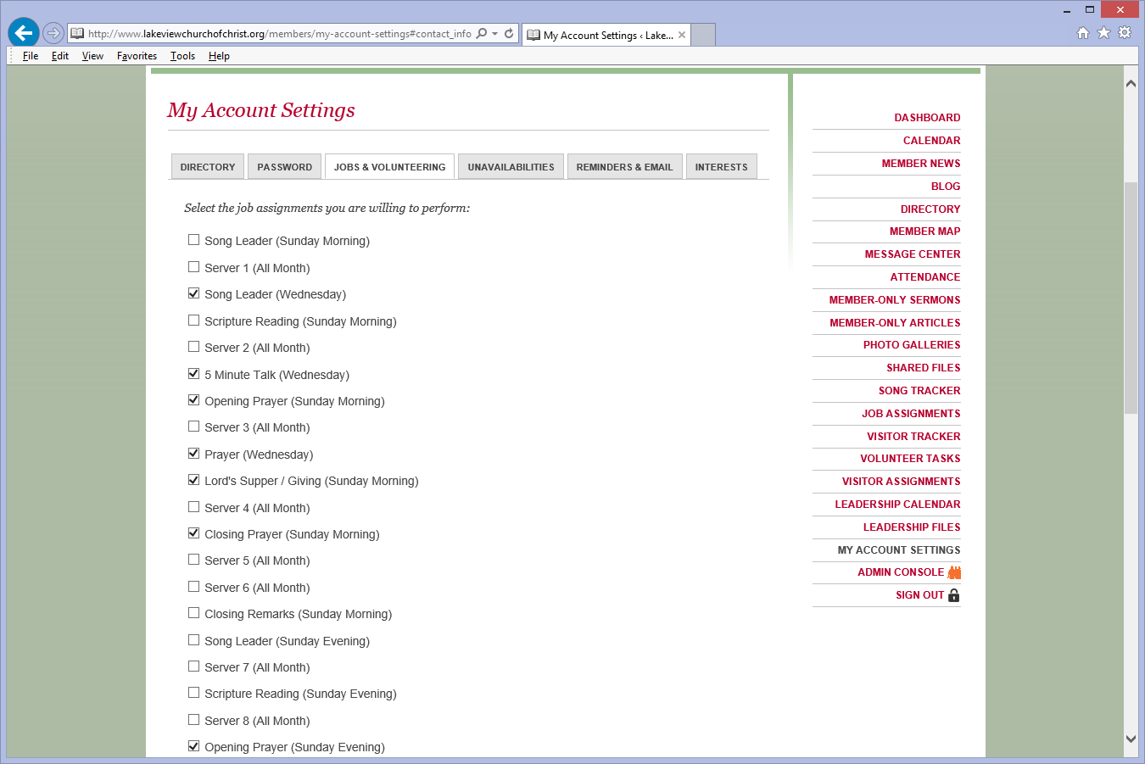

Thanks for taking the time to go through this. Please check back often to see new Job or Tasks that you can sign up for to help our Lord’s kingdom.

Thanks,
Mike

